RIHAM AHAMED ABDUL RAHEEM

HND COMPUTING IDM

E-Commerce Report

Contents

Introduction 1

What is eCommerce security 1

Setup the Secure eCommerce website 2

Ways your website might be attacked 3

1. SQL Injections 3

2. Cross-Site Scripting (XSS) 3

3. Malware infections 3

4. DDoS and DoS 4

5. Brute force tactics 4

Impotence of Communication technology in ecommerce 4

1. Domain Name 4

2. Secure (SSL) Certificate 5

3. Web Hosting 5

4. E-commerce Platform 5

5. Internet Merchant Account (IMA) 5

6. Payment Service Provider (PSP) 5

7. Social Media 5

The role of the database in ecommerce 6

What is a database? 6

Provides Structure 6

Impress the audience 6

Tracking data 7

Product Information 7

Customer Information 7

Transactional Information 7

References 8

**List of figure**

Figure 1: eCommerce website attack 2

# Introduction

The Royal Furnishers (Pvt) Ltd is one of the leading manufacturers of “Quality Furniture” in Sri Lanka. From their beginning, they have focused on producing the finest products thus fulfilling their mission of delivering the highest quality contemporary and ornate furniture to their clientele across Sri Lanka, every time.

The Royal furnishers (Pvt) Ltd is now the business maintain to eCommerce so the customer satisfaction and website privacy and security are most important.

# What is eCommerce security

Security is the most important aspect of an e-commerce website, or at least it should be. Without proper security, online business owners can expose themselves, their brand, and their customers to fraud or identity theft. Failure to provide the leaked credit card details could put pressure on your accounts and cause significant damage to your business.

Do not think that your business is safe because it is small now. The truth is, small businesses are actually more often targeted than large companies. Cybercriminals on small business electronics websites expect little or no security.

They are not wrong. Small e-commerce sites are constantly under threat. Data from cybersecurity firm Imperva indicates that malicious bots make up 29% of Internet traffic, almost a third of them.

It is true that fraud, security, or data breaches can damage your brand's reputation. If you do not spend money on an unsafe website, why should your customers feel the need to spend money safely with you?

Once a breach occurs, it can be difficult for you to get customers back, and new ones are very rare.

Therefore, e-commerce security is about ensuring that both your business and your customers are safe. (Khan, 2020)

# Setup the Secure eCommerce website

Starting an online business and creating an e-commerce website can be a fun and exciting challenge. After all, the market is growing, and if you do it right, early retirement may be on the horizon.

But one thing that many new entrepreneurs overlook or forget is the security of their e-commerce website.

Fortunately, there are many simple preventive steps you can take to protect your website. You don't have to be a computer whiz to implement them. (Khan, 2020)

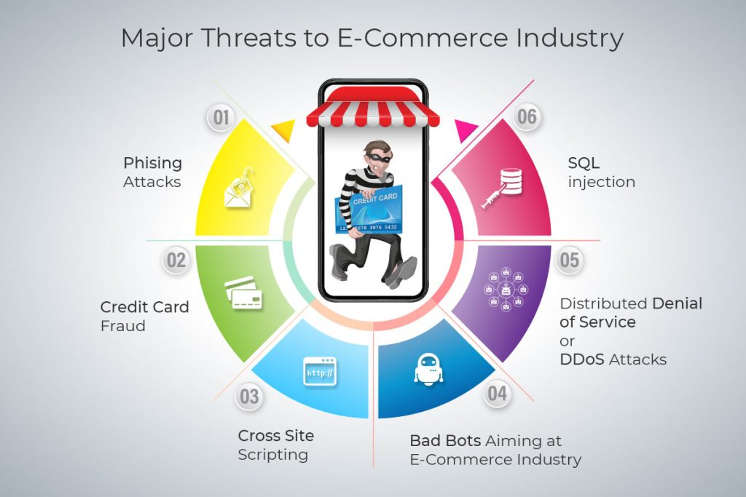

Figure 1: eCommerce website attack

## Ways your website might be attacked

### SQL Injections

SQL is pronounced as a structured query language. With this, a user can manipulate databases and execute commands such as data retrieval and data removal.

SQL injections are one of the most common attacks out there, using unauthorized commands to gain unauthorized access to confidential data stored in the database.

There are three main types of SQL injections

**In-band SQL injection:** is simple and efficient, making it one of the most common SQL injection attacks. It uses the language you use to communicate with your database and display important information or obtain administrative rights.

**Inferential SQL Injections**: or blind SQLi, sends data packets to the attacker's server, which allows it to monitor the server's responses and behavior. It tells them how the server is configured.

**Out-band SQL Injection:** can only be paid if certain functions are enabled on the server used by the web application. It relies on your website's server's ability to generate DNS or HDTP requests, which will eventually transfer the data to the attacker.

### Cross-Site Scripting (XSS)

Cross-site scripting, also known as XSS, is an injection attack on your website's client-side code. The purpose of an XSS attack is to execute malicious and malicious scripts in a web browser by injecting code into a legitimate webpage.

Also, an XSS attack may destroy your website. Your content may change, or if an attacker uses an XSS attack to divert traffic to your website, they may transfer it to another website.

### Malware infections

Malware is another common way for attackers to access your e-commerce website. Malware includes viruses, ransomware, spyware, worms, and all sorts of bad things.

The main thing that malware can do is steal customer information, erase data, infect website visitors and hold your website hostage.

### DDoS and DoS

Denial of Service (DoS) Attacks and Distributed Denial of Service (DDoS) attacks are one of the most common, and the most annoying, security attacks you may encounter. Both are implemented with the same objectives but are technically different.

**DoS attacks** are attempts to shut down your e-commerce website by spamming it with flood or illegal traffic.

**DDoS attacks** also block your site traffic. Your e-commerce website has been affected by malware causing further damage.

### Brute force tactics

This is the attackers' last attempt to shut down a website because of how it works. Brutal attacks use a botnet to guess the details of your website administrator.

The best ways to combat brutal attacks are captcha challenges, two-factor authentication, and complex passwords on your website.

(Khan, 2020)

# Impotence of Communication technology in ecommerce

Communication technology has made a huge difference globally. It also makes a huge contribution to the field of e-commerce. Communication technology plays an important role in e-commerce to successfully overcome the security challenges mentioned above and attract customers.

It is very important that you know what communication technology is being used so that you can offer the best shopping experience to your target audience. These are the key techniques used:

## Domain Name

First, you need to register a domain name for your company. It should be as close to your brand as possible and related to the products you sell. Also, it should be memorable and easy to pronounce.

## Secure (SSL) Certificate

An SSL certificate allows secure communication between a user's web browser and the server that hosts his or her website; In some cases, the web hosting company can provide it to you.

## Web Hosting

You must also select a host to host your website on the server. It is important that you choose established and reputable hosts such as Smart Hosting for high speed, working hours, and reliability - the key features of a successful e-commerce business.

## E-commerce Platform

You also need to choose a site where your website will run. These include:

Software as a Service (SASS) - Mass market templates for a small monthly fee, a great way to get started and test water.

of the self-Software - Open-source solutions like Sauce, but with options for customization. This can be a great choice for those with more technical skills.

Bespoke: Developed specifically for your needs, but more expensive than other options.

## Internet Merchant Account (IMA)

IMA is an Internet-prepaid bank account that allows you to handle transactions online. These can be set up using high street bank accounts.

## Payment Service Provider (PSP)

A PSP, or payment gateway, can provide its own payment pages or host your payment pages. Your bank may recommend a PSP when opening an IMA, but it is better to shop to find the best deals.

## Social Media

Social media can be an incredibly powerful tool for online stores to generate store awareness and interest, direct ads, share content, and interact directly with their target audience. You can also provide direct links to purchase products from your eCommerce store.

(Conway, 2018)

# The role of the database in ecommerce

As technology grows, so will the number of people has involved in e-commerce shopping. Electronic commerce is a type of business model that conducts transactions over the Internet. Any store, business, or person selling stores online is considered part of e-commerce.

However, as the industry continues to grow, there is a system running on the backend of every successful eCommerce site; A database. As fast-growing data changes every day, sites need to consider database best practices. By ensuring proper procedures, companies can take full advantage of an active system to store, organize and configure data for the e-commerce site.

## What is a database?

If you've ever heard of a "cloud database" or "database-backed" site, it refers to a site that uses a database. The basic function of a database is to store information that can be easily captured, retrieved, and distributed digitally later. It provides companies with the ability to analyze and track information about products, sales, and customers entering the database.

## Provides Structure

One of the biggest benefits of using a database for e-commerce is the addition of a structure for large-scale store data. No matter how big or small your online store is, infrastructure is needed so that all the information collected will be meaningful and provide useful information. Once the data is configured, the e-commerce application can access it more efficiently.

## Impress the audience

A database system for e-commerce sites to identify customers based on the information collected. Marketing teams can create specific lists using customer data stored in the database, which can be used to guide marketing efforts. If a marketing team has a lot of information, they can identify it and keep in touch with it. This method not only helps to retain customers, but it also helps to win new customers.

## Tracking data

Databases are an integral part of the success of an online trading platform. With the ability to quickly store, organize, and analyze a wide range of data, it is not surprising why databases are essential. With organized and updated data, companies can respond quickly and update based on changing market conditions.

Databases The most common types of data used to store and monitor e-commerce sites are:

### Product Information

Databases help e-commerce sites update and maintain product information. This may include detailed product descriptions, prices, specifications, product reference numbers, promotions, and availability. Updating this information through your database prevents you from changing and posting new data on each individual page of the site by consistently keeping all pages up-to-date with the same information.

### Customer Information

Having customer data for storage and analysis is great for eCommerce sites. Through databases, information such as contact details, names, expense methods, and more can be used for later marketing. For example, personal figures are more relevant to purchasing power. This type of data collection helps to create unique target markets and enhances customer communication, encouraging online trading sites to focus on customer needs and requirements. When you know what a customer wants, problems and issues can be solved very easily.

### Transactional Information

One of the most important tasks that a database can do for an e-commerce site is to monitor and manage transactions. Monitoring each order in an organized manner through the sales funnel is important to keep the business going, with the necessary processing details. The database helps to keep the goods up to date after each transaction such as billing, shipping, purchase orders, etc.

Databases are important for an effective and successful e-commerce site. Whether you have a small business with limited data or a large store with millions of products, databases help you store and organize important data digitally. With so much information to process, the absence of a database in use is impractical. (Rojas, 2019)

# References

Conway, S., 2018. *Technologies Needed to Start an eCommerce Store.* [Online]   
Available at: https://industrytoday.com/technologies-needed-to-start-an-ecommerce-store/  
[Accessed 14 04 2021].

Khan, R., 2020. *How to Secure Your eCommerce Website: 7 Tips.* [Online]   
Available at: https://www.mailmunch.com/blog/secure-ecommerce-website/  
[Accessed 14 04 2021].

Rojas, N., 2019. *The Role of the Database in E-Commerce.* [Online]   
Available at: https://trellis.co/blog/the-role-of-the-database-in-e-commerce  
[Accessed 04 14 2021].